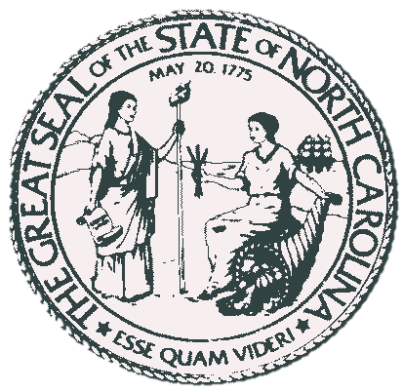

**Proposed Transfer of Land from Federal to State**

**Tuesday, March 12, 2013**

**Total for Transfer to NC**

|  |  |  |  |  |
| --- | --- | --- | --- | --- |
| **Options** | **Acres** | **County** | **Name** | **Owner** |
| Transfer from US | 2341.86 | Dare |  | Bounds of Transfer |
| Transfer within Bounds | 2912.4 | Dare |  | Federal Government |

**Total for Transfer to Federal Options**

|  |  |  |  |  |
| --- | --- | --- | --- | --- |
| **Options** | **Acres** | **County** | **Name** | **Owner** |
| Option Zero | 1,130.58 | Dare | Island | North Carolina |
| Option One | 463.08 | Dare | Buxton Woods North | North Carolina |
| Option Two | 502.96 | Dare | Buxton Woods South | North Carolina |
| Option Three | 953.91 | Currituck | Currituck Banks | NC Coastal Resources |
|  | **3050.53** |  |  |  |

**Ratio 1: 1.05**

Data Sources- This analysis was done based on data sources provided by Dare County for Parcel information and multiple state agencies as listed below:

Municipal and County Boundaries acquired from NC DOT with survey work collected by NC Geodetic Survey

County outlines are from 2009 NCDOT

Parcel Boundaries from Dare County as of January 2013

Federal Parcels shown by owner in Parcel Data

State owned lands shown by owner in Parcel Data

Boundaries for Federal Land boundary digitized from paper Map by Coastal Service

All Data is shown in WGS 83 to match NAIP Imagery 2012. All acreage measurements are calculated by the size of the polygon drawn in ArcGIS.

Counties checked for Possible state options include: Currituck, Dare, Hyde, Carteret, Onslow, and Pender. Only outerbanks areas were taken into consideration except for Hoffman Forest in Onslow County.

**Transfer from Federal to State**

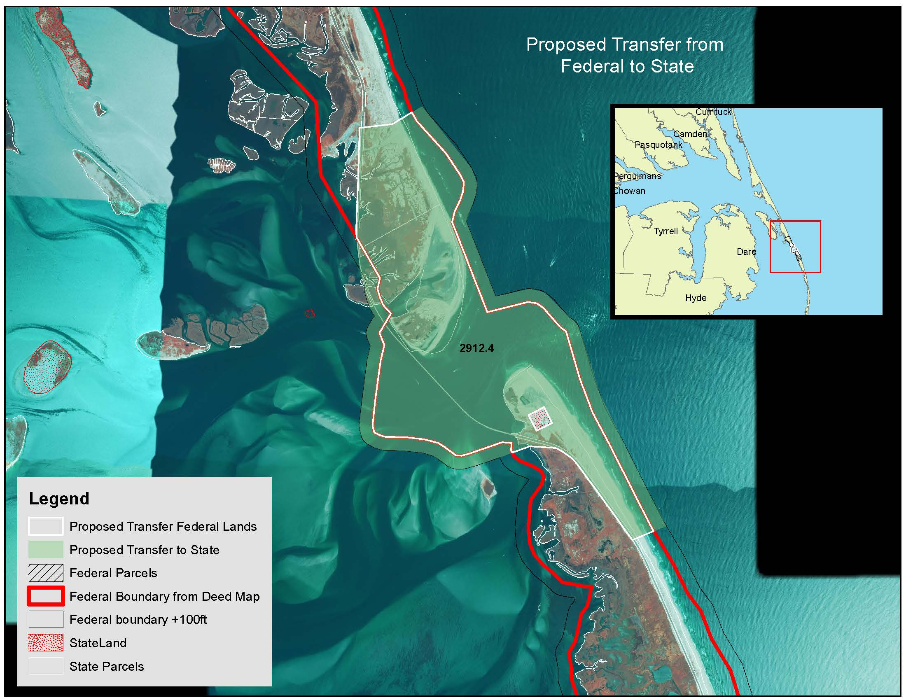

2912.4

Note: Property in purple at south end of the Northern Island is a quick claim deed owned by the Worth Estate. It was put into place 1993. They have been paying taxes on this property.

Property in Yellow has been adjusted to incorporate possible sand movement due to Jetty’s, and clipped to federal land boundary shown in map below

Property in Pink at the northern tip of the southern island shown is Pea Island that North Carolina would like to acquire from federal lands. Small Square in middle has been transferred to NCDOT from Federal government.

**Option Zero- Original Meeting information**

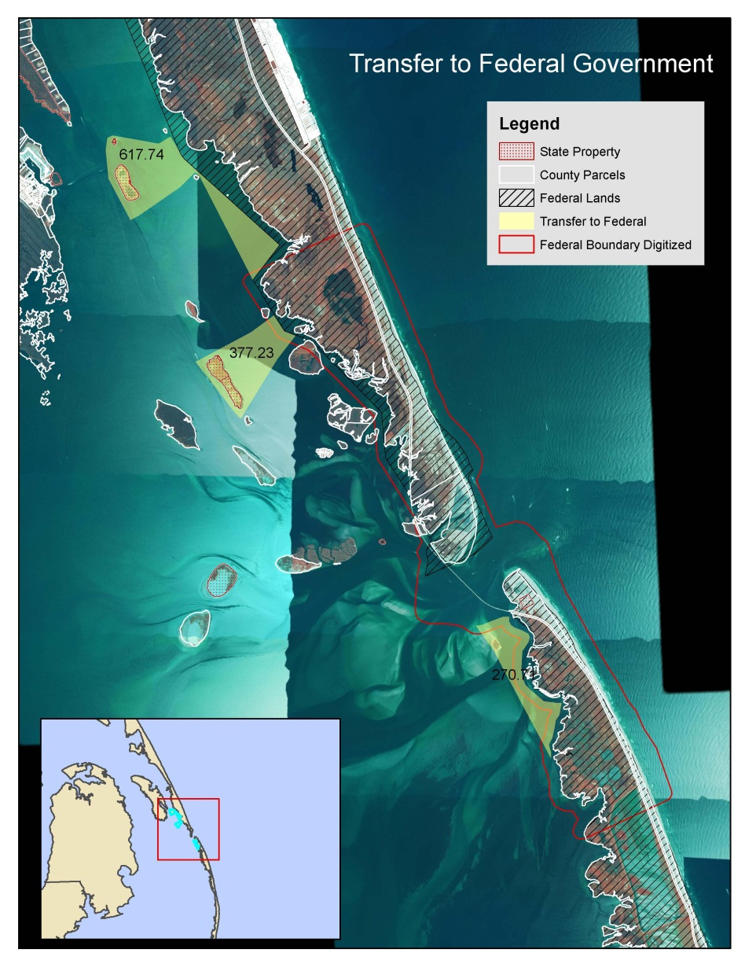

|  |  |  |  |  |  |
| --- | --- | --- | --- | --- | --- |
| **Options** | **Acres** | **County** | **Name** | **Owner** | **PIN** |
| Option Zero | 256.66 | Dare |  | North Carolina | Water |
| Option Zero | 520.51 | Dare |  | North Carolina | Water |
| Option Zero | 270.71 | Dare |  | North Carolina | Water |
| Option Zero | 21.92 | Dare |  | North Carolina | No Parcel # |
| Option Zero | 25.01 | Dare |  | North Carolina | No Parcel # |
| Option Zero | 35.76 | Dare |  | North Carolina | 031113000 |
|  | **1,130.58** |  |  |  |  |

In Northern Polygons, the areas around Federal Bounds were cleaned to the Parcel Lines for the county.

Polygons also clipped to islands to show difference in Land and water area.

Polygon to the south is matched to the Federal Boundary provided.

**Option One and Two - Buxton Woods**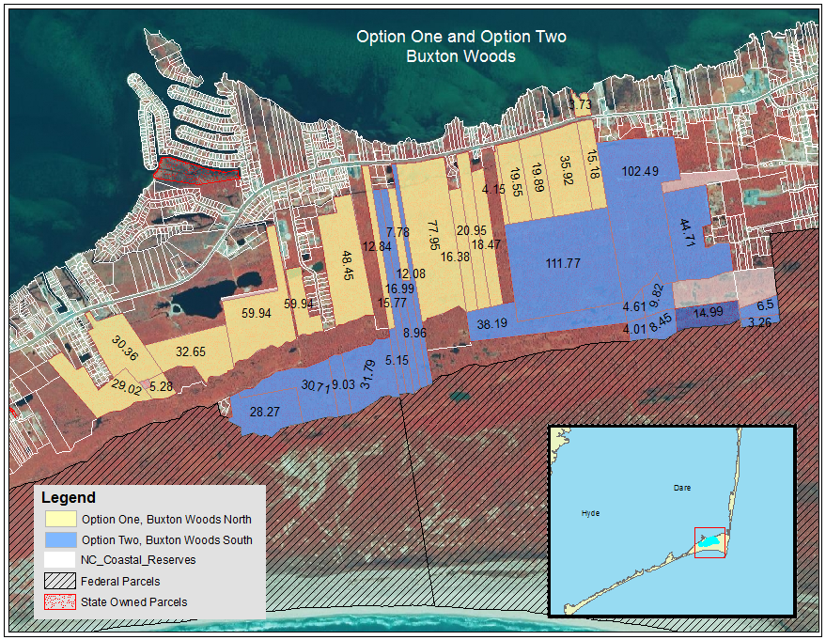

|  |  |  |  |  |  |  |
| --- | --- | --- | --- | --- | --- | --- |
| **Options** | **Acres** | **Area SqFt** | **County** | **Name** | **Owner** | **Parcel** |
| Option One | 30.36 | 1,322,304.11 | Dare | Buxton Woods North | North Carolina | 014939000 |
| Option One | 32.65 | 1,422,168.31 | Dare | Buxton Woods North | North Carolina | 014878009 |
| Option One | 59.94 | 2,610,842.73 | Dare | Buxton Woods North | North Carolina | 026517000 |
| Option One | 29.02 | 1,264,304.26 | Dare | Buxton Woods North | North Carolina | 027397000 |
| Option One | 5.28 | 230,206.06 | Dare | Buxton Woods North | North Carolina | 014967000 |
| Option One | 12.84 | 559,092.60 | Dare | Buxton Woods North | North Carolina | 028152001 |
| Option One | 77.95 | 3,395,388.30 | Dare | Buxton Woods North | North Carolina | 016655002 |
| Option One | 16.38 | 713,308.40 | Dare | Buxton Woods North | North Carolina | 026584000 |
| Option One | 20.95 | 912,623.85 | Dare | Buxton Woods North | North Carolina | 026573000 |
| Option One | 18.47 | 804,754.64 | Dare | Buxton Woods North | North Carolina | 026574001 |
| Option One | 19.55 | 851,388.65 | Dare | Buxton Woods North | North Carolina | 026584000 |
| Option One | 19.89 | 866,202.56 | Dare | Buxton Woods North | North Carolina | 026580000 |
| Option One | 35.92 | 1,564,659.67 | Dare | Buxton Woods North | North Carolina | 012744003 |
| Option One | 15.18 | 661,306.99 | Dare | Buxton Woods North | North Carolina | 026323000 |
| Option One | 48.45 | 2,110,650.69 | Dare | Buxton Woods North | North Carolina | 012744002 |
| Option One | 4.61 | 200,610.40 | Dare | Buxton Woods North | North Carolina | 012744003 |
| Option One | 3.73 | 162,516.71 | Dare | Buxton Woods North | North Carolina | 012744005 |
| Option One | 7.78 | 338,697.54 | Dare | Buxton Woods North | North Carolina | 027392005 |
| Option One | 4.15 | 180,693.83 | Dare | Buxton Woods North | North Carolina | 026304000 |
|  | **463.08** | **20,171,720.30** |  |  |  |  |
| **Options** | **Acres** | **Area SqFt** | **County** | **Name** | **Owner** | **Parcel** |
| Option Two | 30.71 | 1,337,725.99 | Dare | Buxton Woods South | North Carolina | 026517001 |
| Option Two | 28.27 | 1,231,617.37 | Dare | Buxton Woods South | North Carolina | 014878002 |
| Option Two | 14.99 | 652,829.26 | Dare | Buxton Woods South | North Carolina | 026327001 |
| Option Two | 3.26 | 142,076.61 | Dare | Buxton Woods South | North Carolina | 026292003 |
| Option Two | 6.50 | 283,149.66 | Dare | Buxton Woods South | North Carolina | 026292001 |
| Option Two | 15.77 | 686,938.49 | Dare | Buxton Woods South | North Carolina | 026570000 |
| Option Two | 16.99 | 740,255.31 | Dare | Buxton Woods South | North Carolina | 027393000 |
| Option Two | 12.08 | 526,020.31 | Dare | Buxton Woods South | North Carolina | 026582000 |
| Option Two | 111.77 | 4,868,891.84 | Dare | Buxton Woods South | North Carolina | 012744001 |
| Option Two | 102.49 | 4,464,490.43 | Dare | Buxton Woods South | North Carolina | 026324000 |
| Option Two | 44.71 | 1,947,728.22 | Dare | Buxton Woods South | North Carolina | 026327000 |
| Option Two | 9.03 | 393,462.65 | Dare | Buxton Woods South | North Carolina | 026566001 |
| Option Two | 31.79 | 1,384,715.27 | Dare | Buxton Woods South | North Carolina | 015017000 |
| Option Two | 8.96 | 390,241.64 | Dare | Buxton Woods South | North Carolina | 027392004 |
| Option Two | 4.01 | 174,808.42 | Dare | Buxton Woods South | North Carolina | 023846001 |
| Option Two | 38.19 | 1,663,619.74 | Dare | Buxton Woods South | North Carolina | 015019001 |
| Option Two | 9.82 | 427,777.38 | Dare | Buxton Woods South | North Carolina | 026324002 |
| Option Two | 8.45 | 368,094.57 | Dare | Buxton Woods South | North Carolina | 026324001 |
| Option Two | 5.15 | 224,489.70 | Dare | Buxton Woods South | North Carolina | 028152000 |
|  | **502.96** | **21,908,932.90** |  |  |  |  |
| **Option One and Two** | **966.04** | **42,080,653.20** |  |  |  |  |

Buxton woods were split to North and South to show land adjacent to Federal Lands.

NC Coastal Resources Boundaries do not match Properties exactly. Privately owned lands were not included in the parcels shown.

**Option Three - Currituck Banks**

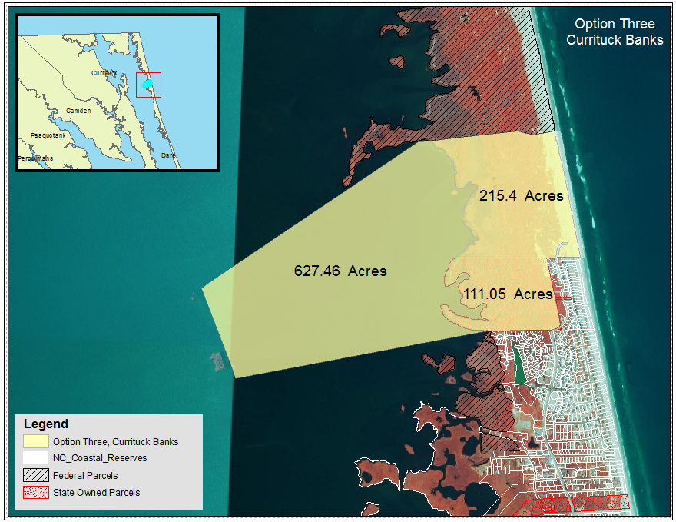

|  |  |  |  |  |  |  |
| --- | --- | --- | --- | --- | --- | --- |
| **Options** | **Acres** | **Area SqFt** | **County** | **Name** | **Owner** | **PIN** |
| Option Three | 111.05 | 4,837,257.95 | Currituck | Currituck Banks | NC Coastal Resources | 9937164497 |
| Option Three | 627.46 | 27,332,170.57 | Currituck | Currituck Banks | NC Coastal Resources | Water |
| Option Three | 215.40 | 9,382,875.90 | Currituck | Currituck Banks | NC Coastal Resources | 9937196038 |
|  | **953.91** | **41,552,304.41** |  |  |  |  |